**9. Rule-Based POS Tagging**

**Aim:**  
To implement rule-based POS tagging using regular expressions.

**Algorithm:**

1. Define regex patterns for different POS tags.
2. Use nltk.RegexpTagger for tagging.
3. Tag the input sentence using the defined patterns.

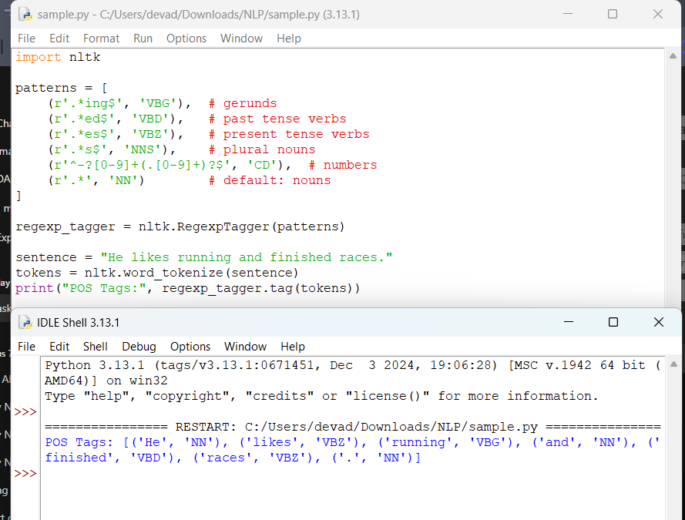

**Result:**  
The program uses regex patterns to perform POS tagging.